 |  | 
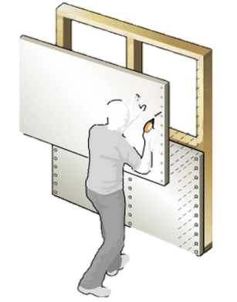 | GROUP MEMEBRS  - Alexandra Villarreal  - Daniel Quezada  - Ivonne Martinez  FCULTY ADVISORS  - Dr. Sarkar  - Dr. Jones
Next Generation Drywall
SENIOR DESIGN I REPORT

Fall 2014
December 04, 2014

Table of Content
Topic
Abstract…………………………………………………………………………………………
List of Figures ………………………………………………………………………
List of Tables ………………………………………………………………………..
I. Introduction (“Elevator Speech”) …………………………………..
II. Problem Formulation
II A. Background Research …………………………………………………
II B. Competitive Products ………………………………………………….
II C. Needs & Wants …………………………………………………………..
II D. Goals & Objectives ……………………………………………………..
II E. Constraints …………………………………………………………………
II F. QFD ………………………………………………………………………………
II G. Gantt Chart ………………………………………………………………….
III. Concept Generation & Selection
III A. Methodology ………………………………………………………………
III B. Functional Decomposition …………………………………………….
III C. Sub-functions ……………………………………………………………….
III D. Conceptual Design ……………………………………………………….
III E. 3D Rendering of Final Design including Dimensions ……..
IV. Design Embodiment
IV A. Engineering Analysis …………………………………………………….
IV B. Design for Manufacturability ………………………………………..
IV C. Bill of Materials …………………………………………………………….
V. Design Validation
V A. Updated Drawings …………………………………………………………..
V B. Test Protocols ………………………………………………………………….
V C. DFMEA ……………………………………………………………………………
V D. Quality Assurance ……………………………………………………………
V E. Safety Issues …………………………………………………………………….
VI. Design History Files (Flash Drive) …………………………………………….
VII. Summary ………………………………………………………………………………..
VIII. References ………………………………………………………………………………
IX. Appendices ………………………………………………………………………………

Abstract

A new market for drywall, the fire-resistant or the Type X drywalls has recently arisen. This Type X drywall provides a fire retardant feature, in order to receive the "Type X" designation under ASTM standards, a gypsum board product must be shown to achieve not less than a one-hour fire resistance rating for 5/8" board or a 3/4-hour fire resistance rating for 1/2" board applied in a single layer. Typical mechanism for fire resistance is the chemical breakdown of the additives in the drywall. Unfortunately, these chemicals release environmentally challenging gases. In this project environment friendly glass nanoparticles are used as an alternative to make Type X drywalls. There are several other advantages of the proposed Type X drywall over the competition. These include the inherent insulation property of the glass nanoparticles to reduce energy consumption in both winter and summer times. In spite of all these features, glass nanoparticles are cost competitive with gypsum and hence expected to be so with more expensive Type X drywalls. The challenge was to make drywall samples that are both similar in engineering specifications and yet reproducible for multiple tests. Drywalls are made millions of square foot with advanced manufacturing equipment. We developed an inexpensive aluminum mold to reliably reproduce 10”X10“ drywall sample with any combination of gypsum, detergents (as foaming agent), water, and glass nanoparticles. This will allow us to compare standard drywall with proposed drywalls with varying amounts of glass nanoparticles, in particular.

It is also expected that this new drywalls will have better acoustic properties due the dispersive nature of dense glass particles. We will validate this assumption by testing the attenuation of sound waves at various frequencies. Knowing the special characteristics of nano-glass particles under a pending patent, the development of The Next Generation Drywall, an improved Type X drywall, is expected to be created. This proposed Next Generation Drywall is expected to be cost competitive with other commercial X drywall. More importantly, this will also address an important environmental issue of removing large amounts (hundreds of thousands of pounds) waste glass every year!

List of Figures
Figure 1. Map of the United States. Color-coded by gypsum wallboard production capacity.
Figure 2. Quality Function Deployment (QFD) for the Next Generation Drywall
Figure 3. Gantt Chart. List of activities for Next Generation Drywall Project
Figure 4. Visual of Tentative Thermal Conductivity Box
Figure 5. Sound Reduction Index Test Set-up
Figure 6. Operation Process Chart for Drywall
Figure 7. Precedence Chart for Drywall Manufacturing Process

List of Tables
Table 1. Competitive gypsum drywalls in the market
Table 2. Design Constraints & Concept Variants for Mold
Table 3. Design Constraints VS. Concept Variants for Mold
Table 4. Cost Sub Function
Table 5. Heat Resistant Sub Function
Table 6. Manufacturability Sub Function
Table 7. Mold Sub Function Winning Score
Table 8. Design Constraints & Concept Variants for Special Gypsum Plaster
Table 9. Design Constraints VS. Concept Variants for Special Gypsum Plaster
Table 10. Strength Sub Function
Table 11. Fire Resistant Sub Function
Table 12. Weight (min) Sub Function
Table 13. Special Gypsum Plasters Sub Function Winning Score
Table 14. Design Constraints & Concept Variants for Testing
Table 15. Design Constraints V.S Concept Variants for Testing
Table 16. R-Value Sub Function
Table 17. ASTM 1396 Sub Function
Table 18. ASTM E119 TEST Sub Function
Table 19. Testing Sub Function Winning Score
Table 20. Bill of Materials for Next Generation Drywall
Table 21. Test Protocols
Table 22. Failure Mode And Effects Analysis for Mold
Table 23. Failure Mode And Effects Analysis for Drywall
Introduction
In the current market, the standard drywall used in most constructions has a price tag of about $8.99 USD per panel. A distributer will sell a minimum of 50 panels. There exist other drywalls that have specific characteristic such as fire resistant, sound proof, high insulation level, damage resistant, and moister resistant. These special drywalls have a higher price due to the quality of the material and construction. Using these higher priced panels are not the first option for a construction company unless specified by the customer or required by law.
The standard drywall panel is made by creating a paste made out of gypsum, soap, and several chemicals that will be placed between two thick external layers of cardboard paper. The standard drywall panel can retard a fire for about 20 - 30 minutes due to evaporation of water particles in the paste. The current weight of drywall panels range from 1.2 to 2.2 pounds per square feet depending on the thickness of the panel. Because of its cheap price, regular drywall panels are the number one option for residential constructions.

In our Senior Design project, we propose to combine glass micro- and Nano-particles to significantly improve the behavior of ordinary drywalls. By combining the gypsum-soap mixture with glass nanoparticles, the insulation level and strength can increase by about 30 percent. Fire retardant behavior is also expected to be significantly better by two to three fold compared to regular drywall panels. Different sizes of glass particles and glass to gypsum-soap mixture ratios will be tested in order to optimize the manufacturing process and resulting performance. Impact testing, weigh support, insulation level, and fire resistance will be tested using a variety of experiments to a regular drywall panel and a glass added drywall panel. Finding a process that can crate drywall panels with fiberglass additive at a close range of cost to a regular drywall panel will create a marked advantage for the new generation of drywall panels.

Creating a drywall panel that has a similar price to a regular drywall panel, but having higher qualities, will result in the replacement of regular panels for the next generation drywall panels in a residential construction. The impact of next generation drywall panels will be very high, due to the increment of safety, reduction of energy usage, and replacement of damage material. Even if the price is slightly high, the added advantage can create a marked advantage in specialized applications like high value homes, commercial properties, etc. The economic impact of the next generation drywall panel can be expected to be range in the millions of dollars, making it an extremely suitable idea to be developed. Since the glass particles are made from recycled waste classes, this application will have an additional positive advantage for the environment.

Problem Formulation
Problem Definition
Currently, fire resistant drywalls are more expensive than regular drywalls and as a result, they are not commonly used in residential constructions.
Next Generation drywall will have the ability to resist to fire, have a better insulation, better acoustic attenuation at an affordable price.

Background Research
In a recent market study by the Global Gypsum, it was found that (http://www.globalgypsum.com/magazine/articles/679-gypsum-wallboard-in-the-usa )
the United States has the largest gypsum drywall industry in the world with a capacity of producing 3,549 million square meters (MM² /year) through out 64 plants in the country operated by seven manufacturers.
The US produces 28% of the world's gypsum wallboard production, making US the biggest drywall manufacturer.
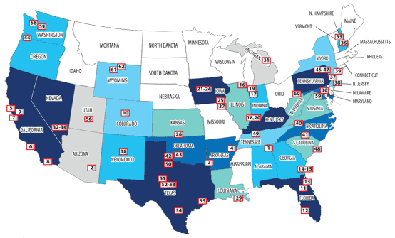
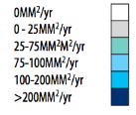

Figure1. Map of the United States. Color-coded by gypsum wallboard production capacity.

The seven producers of gypsum drywall are listed below ranked by capacity of production.

- The largest manufacturer in the US is USG with a capacity of 835 M m²/yr.
- The second largest is National Gypsum with a capacity of 830 M m²/yr.
- Georgia Pacific with a capacity of 600 M m²/yr.
- CertainTeed Gypsum with a capacity of 500 M m²/yr.
- American Gypsum with a capacity of 368.6 M m²/yr.
- PABCO with a capacity of 147 M m²/yr.

Competitive Products

COMPETITIVE PRODUCT SUMMARY
Features | Toughrock | Gold Bond | SHEETROCK | Continental BP
Firecheck® Type X | ✔ | ✔ | ✔ | ✔
Weight (5/8" x 4' x 8') | 70.4 lb | 70.4 lb | 70.4 lb | 72.32 lb
Noncombustible gypsum core |  |  |  | ✔
Glass fibers |  |  |  | ✔
Flexibility | ✔ | ✔ | ✔ | ✔
Price | $10.97 | $10.97 | $9.14 | $10.97
GridMarX® guide marks |  | ✔
GREENGUARD Certified |  | ✔ |  | ✔
Company | Georgia Pacific | National Gypsum | USG | Continental BP
Table 1. Competitive gypsum drywalls in the market

The most popular fire resistance gypsum drywalls in the market are: Toughrock manufactured by Georgia Pacific, Gold Bond by National Gypsum, SHEETROCK by USG and Continental BP by Continental BP with a price that range between 9 to 11 dollars as shown in Table 1. These drywalls share some of its features as flexibility and that they are considered Type X products, which means that they provide a greater fire-resistance than regular gypsum board of the same thickness. Continental BP drywall is the only one out of the 4 that uses glass fibers for the core in order to increase the fire resistibility.

Needs & Wants
In order to know which qualities next generation drywall should have, a study of needs and wants is performed. This helps to know how much the customer is willing to pay for the product and the characteristics and features that they are expecting of the product. The needs and wants for next generation drywall are listed explained below

Needs
The needs for next generation drywall, which are the customer requirements, are:
- The customer requires a high quality product on a affordable cost less than $12 per sheet
- Next Generation should be fire resistant
- Should meet the requirements of the ASTM E 119, which describes the standard test methods for fire test of building construction and materials
- Should meet the specifications of the Type-X Standard providing a high fire resistance
- And the ASTM C1396 that specifies the way the gypsum drywall should be made.

Wants
The wants for next generation drywall, which are the customer expectations, are:
- Next Generation drywall is expected to be a lightweight product, weighting no more than 71 pounds per sheet.
- Customer expects a good quality product and,
- High performance Drywall

Goals and Objectives

Goal
The goal of this project is to develop Next Generation Drywall with advanced features like high thermal Insulation, excellent fire retardation, and acoustic attenuation. As well as sustainable design methodology using recycled glass.

Objectives
The objectives of the project are: to increase thermal insulation of the drywall by 30% using Nano glass particles, prolongation of fire retardant capacity to more than 20 minutes, maintain weight of the drywall under 2.2 pounds per square feet and to keep final product cost below eleven dollars

Constraints

Design Constraints
One of the project constraints is to identify and obtaining the necessary raw materials to manufacture The Next Generation Drywall.
Next Generation Drywall needs to be manufactured to a consensus standard, ASTM C1396, Standard Specification for Gypsum Board. This standard is referenced in building codes such as the International Building Code, International Residential Code, and the National Fire Protection Association (NFPA) 5000: Building Construction and Safety Code.
Project Constraints
This Next Generation Drywall not only will be manufactured under de ASTM standards but the process must sustain a low variance production, ensuring consistency to the production.
To ensure accuracy in the testing phase of the project, it necessary to have appropriate equipment is.

Quality Function Deployment (QFD)
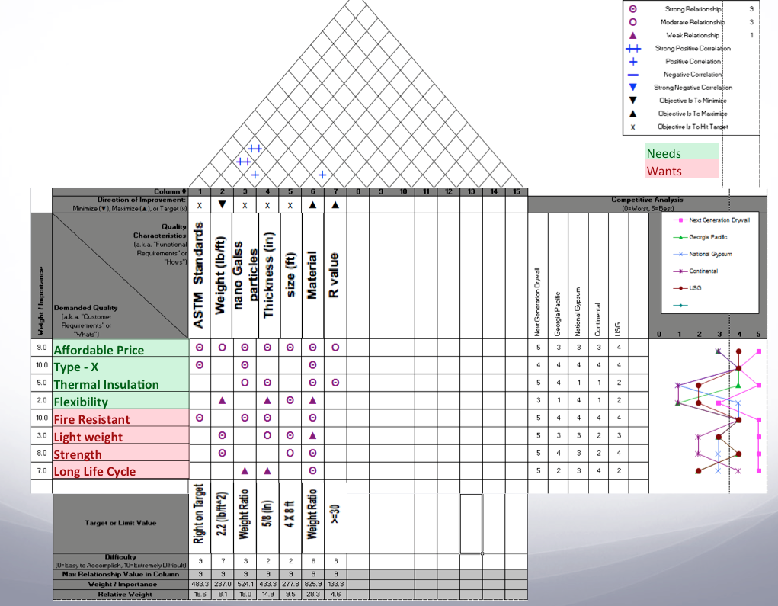
Figure 2. Quality Function Deployment (QFD) for the Next Generation Drywall
The quality function deployment translates the customer requirements and expectations, market research and technical benchmarking, previously mentioned, into engineering targets to be met by Next Generation drywall.

The customer requirements, as seen in the Figure 2, are ranged based on the importance that they have in the production of the product (10 being the most important and 1 the less important). The Next Generation drywall should be fire resistance (10), affordable price (9), meet the requirements to be considered a Type X product (10), have a high thermal insulation (5), flexibility (2), lightweight (3), high strength (8) and long life cycle (7).

The engineering requirements for Next Generation drywall are: follow the ASTM Standards, weight (lb/ft), Nano glass particles (%), thickness (in), size (ft), what type of material is going to be used and R- value.

QFD provides a competitive analysis in order to compare Next Generation Drywall with other products in the market regarding the customer requirements using a scale of 0 to 5, worst and best respectively. As seen in the Figure 2, the best product is Next Generation Drywall having the highest score for 7 out 0 customer requirements making it a very competitive product in the market, following by USG being the second best product having high scores in affordability, type X, fire resistivity and strength.

The conclusions drawn from the entire matrix can be found in the target section located at the bottom of the QFD as shown in Figure 2. The targets or limit values for Next Generation Drywall are the following:

- The ASTM Standards are met
- The weight of the drywall should be no more 2.2 pounds per square feet
- Next generation drywall should have a thickness of 5/8 inches,
- A weight ratio of Nano glass fibers,
- Size of 4 per 8 feet
- And a R value greater than 30

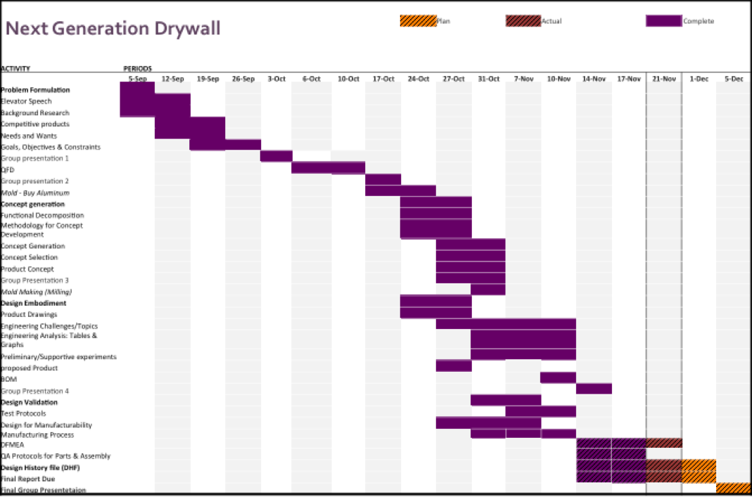
Gantt Chart
Figure 3. Gantt Chart. List of activities for Next Generation Drywall Project

The Gantt chart (Figure 3) shows the color-coding project schedule, illustrating the start and finish dates of the activities. The yellow represents an activity that is not yet started but is planned, purple represents a task that is completed, yellow represents an activity that is started but not yet finished.

Concept Generation & Selection

Methodology
To develop the next generation drywall, a series of steps we taken. First, in order to understand the market, a competitive product analysis was done. Followed by a process research and a functional decomposition. All drywalls are manufactured to a consensus standard the ASTM C1396, Standard specifications for Gypsum Board. To create the next generation drywall a competitive product, the ASTM C1396 standards for gypsum drywall and the ASTM E 119 test, Standard Test Methods for Fire Tests of Building Construction and Materials were taken in consideration at the brain storming process.
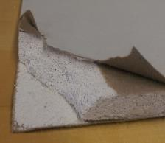
Thick Sheet of Paper
Gypsum Plaster
Typical Construction Process
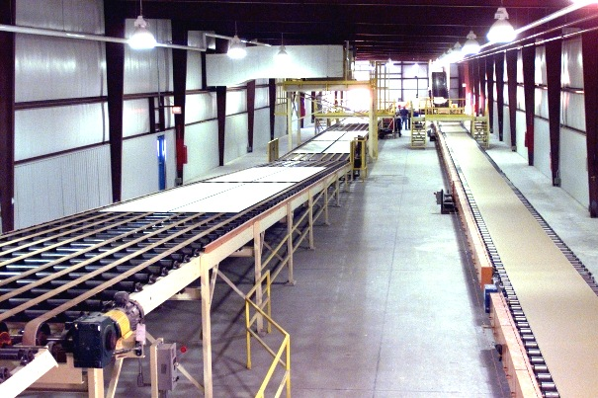
A drywall it’s a panel made of gypsum plaster pressed between two thick sheets of paper, this are the main components in the creation of drywall. The cover is just a thick sheet of cardboard paper and the special gypsum plaster is composed of powder gypsum, water, soap, minerals and other chemicals. To produce a drywall, the powder gypsum is mixed with water and other chemicals, which is fed between continuous layers of paper on a board machine. As the board moves down a conveyer line, the calcium sulfate recrystallizes or rehydrates, reverting to its original rock state. The paper becomes chemically and mechanically bonded to the core. The board is then cut to length and conveyed through ovens that dries and removes any moisture from the gypsum plaster.

Functional Decomposition
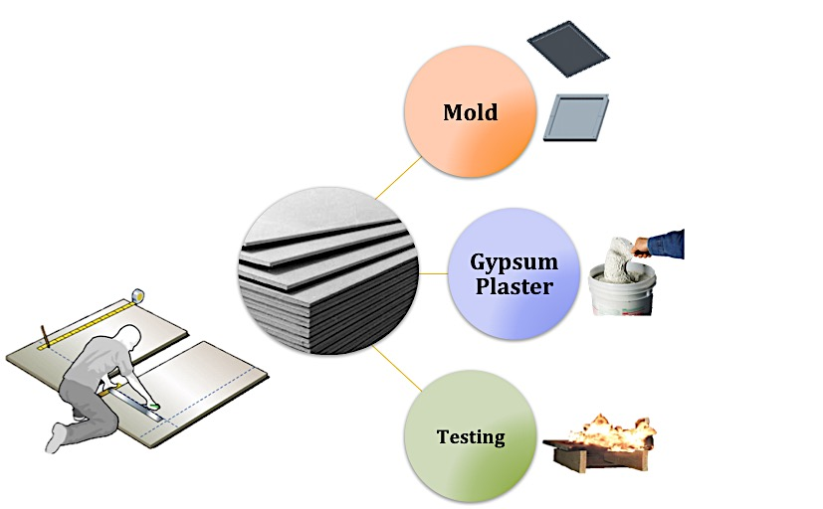
The next generation drywall project has three sub functions that comprise the functional decomposition. This sub functions are the mold, special gypsum plaster, and testing. This three sub functions are the main components for the manufacturability of the next generation drywall prototypes.

Sub-Functions

Sub Function I – Mold
The first sub function is the mold. The creation of the mold is the first step on the production of the drywall prototypes. In order to replicate the regular process, from a mass production to a 10” by 10” prototype process, a design of a mold was generated in order to satisfy the production constraints. This mold is designed to hold the gypsum plaster between the cardboard papers under pressure and have the ability to dry the gypsum under high temperatures inside an oven. The use of the mold is also to develop identical samples for comparison in the testing phase. The design constraints are the cost, heat resistant and manufacturability and the concept variants are steel, aluminum and plastic.

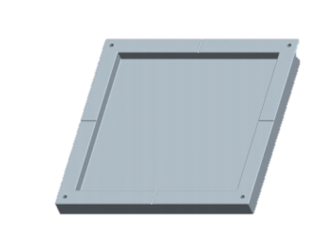
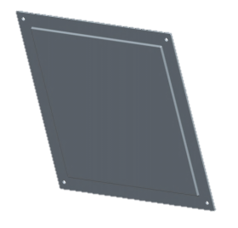
Design Constraints
Cost
Heat Resistant
Manufacturability
Concept Variants
Steel
Aluminum
Plastic
Table 2. Design Constraints & Concept Variants for Mold

The following tables show the calculations made for the mold constraints and variants in order to find the material need to manufacture the mold. Within our constraints, heat resistant is the heist design constraints having a 0.50 nominal score as seen on the Table 3.

Mold | Cost | Heat Resistant | Manufacturability | Row Sum | Nominal Score  (Rel. Weight)
Cost |  | 2 | 2 | 4 | 0.222
Heat Resistant | 4 |  | 5 | 9 | 0.500
Manufacturability | 4 | 1 |  | 5 | 0.278
Col. Sum | 8 | 3 | 7 | 18 | 1.000
Table 3. Design Constraints VS. Concept Variants for Mold

The variants selected for this sub function are the different types of materials that the mold can be done. On Tables (4 to 7) the variants for the mold compete with each other in each different constraint category order to find the wining material for the mold.

COST (min) | Steel | Aluminum | Plastic | Row Sum | Nominal Score (Rel. Weight)
Steel |  | 2 | 1 | 3 | 0.167
Aluminum | 4 |  | 2 | 6 | 0.333
Plastic | 5 | 4 |  | 9 | 0.500
Col. Sum | 9 | 6 | 3 | 18 | 1.000
Table 4. Cost Sub Function

Heat Resistant > 450° C | Steel | Aluminum | Plastic | Row Sum | Nominal Score (Rel. Weight)
Steel |  | 4 | 5 | 9 | 0.500
Aluminum | 2 |  | 5 | 7 | 0.389
Plastic | 1 | 1 |  | 2 | 0.111
Col. Sum | 3 | 5 | 10 | 18 | 1.000
Table 5. Heat Resistant Sub Function

Manufacturability | Steel | Aluminum | Plastic | Row Sum | Nominal Score (Rel. Weight)
Steel |  | 2 | 2 | 4 | 0.222
Aluminum | 4 |  | 5 | 9 | 0.500
Plastic | 4 | 1 |  | 5 | 0.278
Col. Sum | 8 | 3 | 7 | 18 | 1.000
Table 6. Manufacturability Sub Function

 | Cost | Heat Resistant | Manufacturability | SCORE
Steel | 0.037 | 0.250 | 0.062 | 0.349
Aluminum | 0.074 | 0.194 | 0.139 | 0.407
Plastic | 0.111 | 0.056 | 0.077 | 0.244
Table 7. Mold Sub Function Winning Score

Aluminum it’s the wining material for the mold. This material meets all the design constraints because it provides low cost, easy to manufacture and most important it will resist the temperature from the oven.

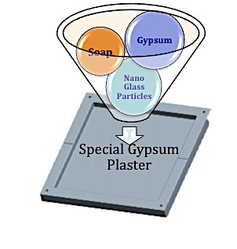
Sub Function II – Special Gypsum Plaster
This second sub function is the special gypsum plaster. This is the second phase of the making of the next generation drywall. The variants in this sub function are gypsum, Nano glass particles and cook time, in order to have a competitive product the next generation drywall must meet the design constraints. The design constraints are strength, fire resistant and weight, and they all depend on the concept variants. The following tables show, which is the wining variant for the gypsum plaster.

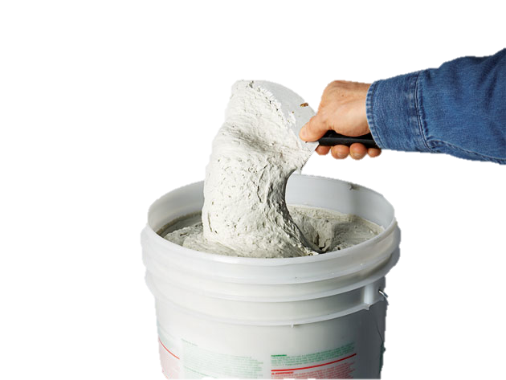

Design Constraints
Strength
Fire Resistant
Weight
Concept Variants
Gypsum
Nano Glass Particles
Cook Time

Table 8. Design Constraints & Concept Variants for Special Gypsum Plaster

To have a competitive product, strength, fire resistant and weight are critical constraints. The next generation drywall must meet all three, but as Table 9 reveals that the fire resistant is the most important factor in the design constraints for the special gypsum plaster having a 0.556 nominal score.

Gypsum Plaster | Strength | Fire Resistant | Weight | Row Sum | Nominal Score (Rel. Weight)
Strength |  | 1 | 4 | 5 | 0.278
Fire Resistant | 5 |  | 5 | 10 | 0.556
Weight | 2 | 1 |  | 3 | 0.167
Col. Sum | 7 | 2 | 9 | 18 | 1.000
Table 9. Design Constraints VS. Concept Variants for Special Gypsum Plaster

The following tables display a mathematical model to find the critical concept variant for the special gypsum plaster that will gave the biggest impact on the fire resistant constraint.

Strength | Gypsum | Nano Glass Particles | Cook Time | Row Sum | Nominal Score (Rel. Weight)
Gypsum |  | 2 | 4 | 6 | 0.333
Nano Glass Particles | 4 |  | 4 | 8 | 0.444
Cook Time | 2 | 2 |  | 4 | 0.222
Col. Sum | 6 | 4 | 8 | 18 | 1.000
Table 10. Strength Sub Function

Fire Resistant | Gypsum | Nano Glass Particles | Cook Time | Row Sum | Nominal Score (Rel. Weight)
Gypsum |  | 1 | 4 | 5 | 0.278
Nano Glass Particles | 5 |  | 6 | 11 | 0.611
Cook Time | 2 | 0 |  | 2 | 0.111
Col. Sum | 7 | 1 | 10 | 18 | 1.000
Table 11. Fire Resistant Sub Function

Weight (Min) | Gypsum | Nano Glass Particles | Cook Time | Row Sum | Nominal Score (Rel. Weight)
Gypsum |  | 4 | 2 | 6 | 0.333
Nano Glass Particles | 2 |  | 2 | 4 | 0.222
Cook Time | 4 | 4 |  | 8 | 0.444
Col. Sum | 6 | 8 | 4 | 18 | 1.000
Table 12. Weight (min) Sub Function

 | Strength | Fire Resistant | Weight | Score
Gypsum | 0.093 | 0.154 | 0.056 | 0.302
Nano Glass Particles | 0.123 | 0.340 | 0.037 | 0.500
Cook Time | 0.062 | 0.062 | 0.074 | 0.198
 |  |  |  | 1.000
Table 13. Special Gypsum Plasters Sub Function Winning Score

After analyzing the relationship between the concept variants and the design constraints, the Nano glass particles are the most important concept variant having a 0.50 of total score. This will be the key ingredient for the special gypsum plaster that the next generation drywall will have.

Sub Function III – Testing
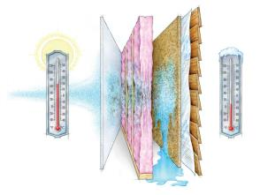
The testing sub function is the last phase for completing the project. In this phase the testing of the prototypes will take place. According to the background research the ASTM standards for gypsum drywalls are the ASTM 1396 and the ASTM E 119. It is important to develop a product that will be competitive therefore the design constraints for the testing sub function are, R-Value, ASTM 1396 and ASTM 119 and the concept variants are volume, percent of Nano glass particles and temperature.

Design Constraints
R-Value
ASTM 1396
ASTM E119 TEST
Concept Variants
Volume
% Nano Particles
Temperature
Table14. Design Constraints & Concept Variants for Testing

The next generation drywall must meet and pass the fire codes, the International Building Code and have a high R-Value. To that end all the design constraints are important in the testing phase of the project, equivalently the concept variants are as important. The table below indicates that the ASTM E 119 with a 0.444 nominal score is the fundamental constraint that will develop better results for the prototype analysis.

Testing | R-Value | STC 57 | ASTM E119 TEST | Row Sum | Nominal Score (Rel. Weight)
R-Value |  | 4 | 3 | 7 | 0.389
ASTM 1396 | 2 |  | 1 | 3 | 0.167
ASTM E119 TEST | 3 | 5 |  | 8 | 0.444
Col. Sum | 5 | 9 | 4 | 18 | 1.000
Table15. Design Constraints V.S Concept Variants for Testing

The following tables demonstrate which of the variants are more important for better testing results.

R-Value | Volume | % Nano Particles | Temperature | Row Sum | Nominal Score (Rel. Weight)
Volume |  | 2 | 1 | 3 | 0.167
% Nano Particles | 4 |  | 4 | 8 | 0.444
Temperature | 5 | 2 |  | 7 | 0.389
Col. Sum | 9 | 4 | 5 | 18 | 1.000
Table 16. R-Value Sub Function

ASTM 1396 | Volume | % Nano Particles | Temperature | Row Sum | Nominal Score (Rel. Weight)
Volume |  | 4 | 6 | 10 | 0.556
% Nano Particles | 2 |  | 5 | 7 | 0.389
Temperature | 0 | 1 |  | 1 | 0.056
Col. Sum | 2 | 5 | 11 | 18 | 1.000
Table 17. ASTM 1396 Sub Function

ASTM E119 TEST | Volume | % Nano Particles | Temperature | Row Sum | Nominal Score (Rel. Weight)
Volume |  | 2 | 3 | 5 | 0.278
% Nano Particles | 4 |  | 4 | 8 | 0.444
Temperature | 3 | 2 |  | 5 | 0.278
Col. Sum | 7 | 4 | 7 | 18 | 1.000
Table 18. ASTM E119 TEST Sub Function

 | R-Value | ASTM 1396 | ASTM E119 TEST | Score
Volume | 0.0648 | 0.0925 | 0.123 | 0.281
% Nano Particles | 0.172 | 0.06481 | 0.198 | 0.435
Temperature | 0.15123 | 0.00925 | 0.123 | 0.284
Table 19. Testing Sub Function Winning Score

With an over all score of 0.435 the percent of Nano glass particles is the wining variant that will give the best testing results.

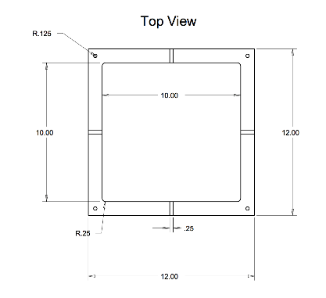
Conceptual Design
(a)
According to the sub function analysis, the mold should be manufactured using aluminum. The team proposed the following dimension for the mold; body 10” X 10” X 5/8” and two lids that will provide the ability to have two different thicknesses 1/2” and 5/8”. This will offer repeatability and accurateness for the testing phase. The objective is to minimized or eliminates variance in the drywall thickness; this variance might affect the results for the testing analysis. Using the software PTC Creo Parametric the mold design was created. Picture (a) and (b) are the first drawings and 3D representation of the mold design.
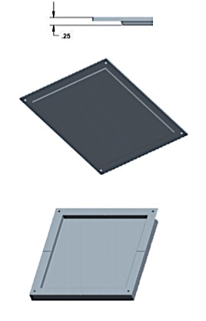
(b)
3D Rendering of Final Design
The proposed dimensions of 10” X 10” X 5/8” for the body and 1/2” and 5/8” for the two lids were approved and selected for the mold. The mold and lids were manufactured by milling aluminum blocks using a manual milling machine. The mold is capable to hold the cardboard paper and the special gypsum plaster, which will have Nano-glass particles, gypsum and other chemicals. The lids will safely close delivering enough pressure to make an even surface and volume drywall sheet. This mold will handle the oven temperatures for the cooking process.

Design Embodiment
Engineering challenges
- Standardized Samples
In order to present data that is effective, it is extremely important that the protocols for testing as well as the test themselves must be standardized. This approach will result in data that is expected to have low variance in the results. It is also recommended that, while the tests are being run statistical control procedures be applied to the data obtained.
The first step in the validation of the prototype is the control of the critical measurements as it is weight to Nano-glass particles ratio, Volume of the prototype, and finally, size and thickness. In order to proceed to testing, these measurements must be in control using standardized manufacturing processes. The generation of control charts as the statistical distribution of these measurements will be created. The usages of excel spreadsheets and Minitab spreadsheets will facilitate this step into the manufacturing of the prototypes.
After the prototype samples are confirm to be standardized, the next step is to validate the data that will be obtain form the applied tests that will be detailed latter on in this report. It is expected that fire endurance and sound reduction index have a positive linear relationship with the percentage of Nano-glass particles inside the gypsum drywall panel. Similarly, thermal conductivity and the weight of the panel are expected to have a negative linear relationship to the percentage of glass nanoparticles inside the gypsum board panels. This expectations will be confirm using an analysis of variance and linear regression analysis of the data obtain form the tests.

- ASTM E 119-00a
The fire test methods found in the ASTM E 119-00a applied for materials used in the construction business. They follow very specific steps in order to provide a result according to specific measurements. It is important to mention that these tests are run with standard samples that can be found in any construction environment. Because the budget of the next generation drywall team is limited, as well as the resources for testing available in the lab, these test methods will be modified in order to obtain results.
The test that the next generation drywall team will be using is the fire endurance test. This test will be slightly modified in order to fit the features of the samples tested. The prototypes that will be tested are 5/8” x 10” x 10” and ½” x 10” x 10”, in contrast to the samples tested with the ASTM E 119-00a that are regular 5/8” x 4’ x 8’. Also, the temperatures that the ASTM E 119-00a standard follows are very specific using specialized equipment. These temperatures will be to be modified in order to obtain the result.

- Acoustic Test
Given that the resources available to the next generation drywall are limited, the acoustic test will need to be adjusted.

Engineering Analysis

Thermal Conductivity
One of the features that the next generation drywall team is looking to ensure in its product is the reduction of thermal conductivity. The reduction of thermal conductivity in the next generation drywall will result in the reduction of energy usage to keep the temperature of a room as mention before. In order to ensure that the product is in fact reducing thermal conductivity, a test for the calculation of R-value will be created. This test will consist on the creation of a box with an insulating base. The wall of the box will be made out of the next generation drywall with several percentages of glass nanoparticles. The insulting bottom will be out of polystyrene board where several light bulbs will be placed. The light bulbs will be of 100 watts disperse evenly trough out the area of the polystyrene bottom. These light bulbs will function as the control temperature of the box in order to calculate the loss of heat. Thermal couples will be placed on each of the walls made out of gypsum on the outside face of the box. The thermal couples will provide with the temperature outside the gypsum walls to calculate the R-value. Because the boards will be created with specific are and thickness, the length through which heat flux is running will be known. Given all that all the information mention is available the next equation will be use in order to calculate the R-value:

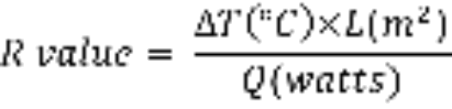

Where:

∆T =Change in Temperature(°C)
L = Length (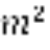)
Q = Heat Flux (watts)

The percentages that will be used in the mix in order to test the R-values are 0%, 10%, 20%, and 30%. The 0% of glass nanoparticles in the mix will be used as the control group so the other percentages can be compared. This method will verify that the thermal conductivity indeed has a negative linear relationship with the percentage of glass nanoparticles as mention before. Several tests following the same procedure will be run in order to recollect data, and a proper analysis can be implemented.


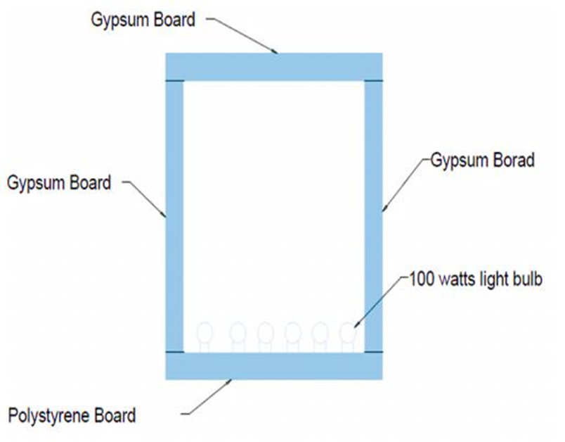
Figure 4. Visual of Tentative Thermal Conductivity Box

Figure 4 shows in a basic visual how the experiment will be run, and how the wall will be tested. The polystyrene in the bottom will assure that the heat of the 100 watts light bulbs will flow through the gypsum boards. Also, thermal couples will be place on the outside of the gypsum walls in order to measure the temperature that is escaping out of the box.
In order to ensure that the test is run appropriately, a thermal couple will be placed inside de box in order to verify when the temperature reaches a constant measurement. After this temperature inside the box is reach, then the outside thermal couples readings can be taken into consideration. Failure to have a constant temperature inside the box will provide with readings that latter on the experiment will change, and the whole data up to that point will be useless.

Sound Reduction
Another feature that will be tested in the next generation drywall is the acoustic capabilities. The reduction of sound will ensure that noise from a different room, or outside the house will be reduce. This means that the people using t a room with acoustic capabilities will be more comfortable inside the room. In order to ensure that glass nanoparticles do have an effect in the acoustics of the next generation drywall, a sound reduction test will be implemented. The test will consist in the construction of a box made out of next generation drywall with some music-playing device inside to generate sound. The sound pressure inside the box will be measure with a digital sound level meter. Also, the outside sound pressure will be measure so the comparison of sound reduction can be made. Due to the fact that the next generation drywalls will have standard measurements, the following equation will be implemented in order to calculate the sound reduction index:

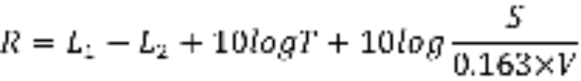

Where:

R = Sound reduction index
L1 = Average sound pressure level in the source room (Pa)
L2 = average sound pressure level in the receiving room (Pa)
S = Area of the test specimen ()
T = Reverberation time in the receiving room (hours)
V = Receiving Room Volume (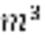)

The percentages that will be used in the mix in order to test the sound reduction index are 0%, 10%, 20%, and 30%. The 0% of glass nanoparticles in the mix will be used as the control group so the other percentages can be compared. This method will verify that the sound reduction index indeed has a positive linear relationship with the percentage of glass nanoparticles as mention before. Several tests following the same procedure will be run in order to recollect data, and a proper analysis can be implemented.

It is important to measure that in order to have the best results possible, this test method could vary slightly. Instead of testing only one box, it is possible that the need for a second box is present. This is because the receiving rom volume in the formula will not be constant to the source room (box). Also, instead of using a sound music playing device, a sound wave generator device can be used as a sound source. The reverberation time will depend on the amount of time needed to reach a constant sound pressure.

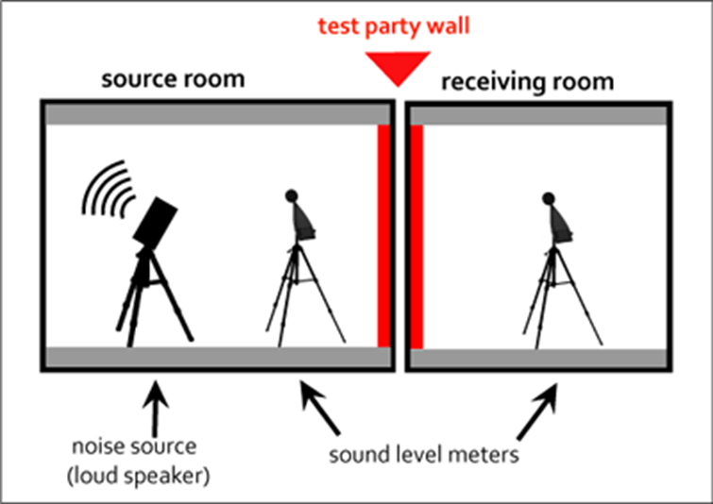
Figure 5. Sound Reduction Index Test Set-up

With the difference of the R-value test, the sound reduction index test will not have a different bottom from next generation drywall. Also, in the sound reduction index test, the measure of the gypsum drywall that will be tested will not be the length but the area of the specimen.

Fire Endurance Test
The fire endurance test will provide an estimate of how much wills the next generation drywall will support against fire. This test will consist of the creation of a wall mount simulation, similar to what is found in any regular residential construction. A fire source will be place close to the mount, or as another option, right next to the wall mount. Every 5 minutes the temperature at which the fire is burning will be measure, and the wall mount will be check. The test will continue to run until the next generation drywall fails. A failure can be taking as cracks along the specimen that will create failure in regular construction site. Also, failure of the gypsum wall along the nails that have it in place on the mount will stop the test. After the experiment is run, the data obtain will be plugged in a time temperature curve as suggested to by the ASTM E 119-00a. This curve will best fit the resistance of the next generation drywall to the temperature rising and the time of exposure.
//

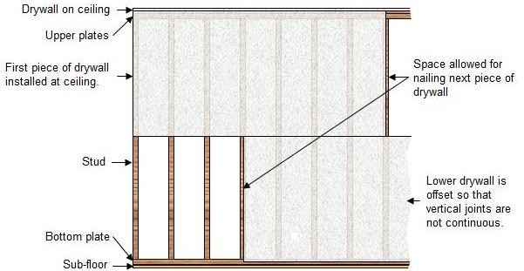
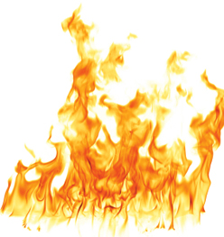
Gypsum Drywall
Wooden Studs
2” x 4”
8 inches
8 inches

This test will follow ASTM E 119-00a as close as possible taking in account the materials use in in the standard testing are regular size materials, and that they use specialized equipment as mention before. Another thing that will need to take in to account will be the fire source. Because the source may not have a constant temperature, it can create a problem to do the calculations. It is important to try to make the source increment in temperature for best results. In the case that the source of fire will use a combustible, the type of combustible as well as the amount use will need to be recorder to have more precise calculations.
Design for Manufacturability

Proposed Product
The resources available for the creation of the next generation drywall dictated the size in length of the prototypes. Because the gypsum dry wall needs to pass by a drying station on its manufacturing process, the length was decided to be 10 inches. This is because the drying station will be done by a furnace available to the team that can only fit samples of about 16 inches long. The thicknesses of the prototypes were decided to be 5/8” and ½” because those are the standard thickness for a fire resistant drywall already in the market. Also, in order to proof the relationship of glass nanoparticles to the sound reduction, fire resistance, and thermal conductivity four different percentages of these particles will be tested. The percentages will be 0%, 10%, 20%, and 30%. The prototype with 0% of glass nanoparticles will serve as the control group, in order to compare the prototypes with 10, 20, and 30 percent of glass nanoparticles present. It is important to state that the comparison between prototypes of the next generation drywall will provide the linear relationship between glass nanoparticles and its already mention features. Once the optimal percentage of glass nanoparticles is found, then a test against type x gypsum drywall will execute. This comparison between products will provide a vision of where the next generation drywall is in the market.
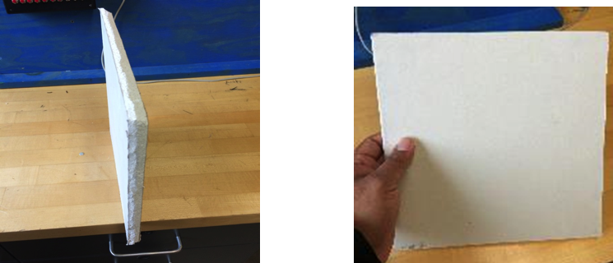
(a)
(b)
Pictures (a) and (b) provide a visual of how the final prototypes will look. All of the samples created will be measure in order to ensure that its size is constant. This prototypes will be used in the test already mention in this report. Once the optimal next generation drywall is found, a regular size type X board will be cut into the same size as the prototype created. The type x drywall will be subject to the same test that the next generation drywall was subject to.

Mold

Because the creation of gypsum drywall as presented to the market require industrial equipment, the next generation drywall team had to came up with an idea that will guaranty the manufacturability of the gypsum drywall prototypes. The most suitable option, due to the resources available to create the next generation drywall, was to use a transfer mold to create the prototypes. It was decided to create the transfer mold out of 6061 aluminum due to is ease in manufacturability as well as its resistance to high temperature and cheap cost.
The inside pocket of the transfer mold will be 5/8” x 10” x 10” and utilize two covers. One will be a flat cover that will make the gypsum board be 5/8” thick, and a second cover with a slight bum that will fit inside the mold pocket and will make the thickness of the gypsum drywall decrease to ½”. The runners on the outside face of the transfer mold will allow for the excess material to squeeze out. These runners are .005” in depth and .25”in width with 1” in length. The round edges of the transfer mold’s pocket were provided to reduce stress in the edges of the prototype.
It is important to mention that the creation of the transfer mold provide with a constant volume as well as a constant size, making the product to be standardize. Also, the mix for the paste of the next generation drywall will be created in a different container, and transported to the transfer mold for its insertion on the furnace.
/
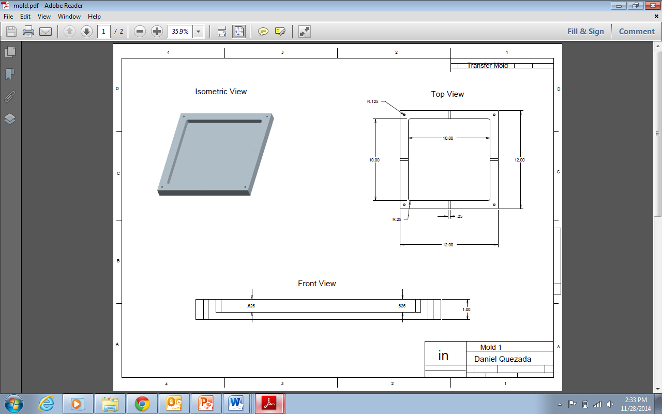

/

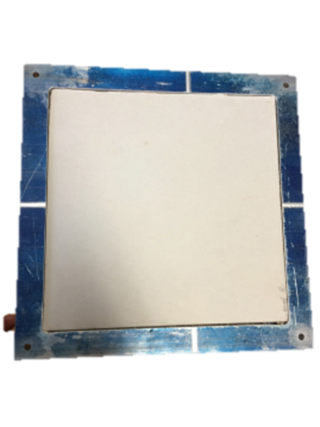
Actual View

Manufacturing process

Operation Process Chart
The creation of the next generation drywall will need to follow a specific manufacturing process in order to reduce the variance on the target features of the product. This manufacturing process has three mayor components from which the creation of the gypsum prototype will derive. The first component of the manufacturing process is the gypsum preparation, the second is the chemical mixing, and the third is the molding of the product. The following is the required OPC to follow according to the already mention.

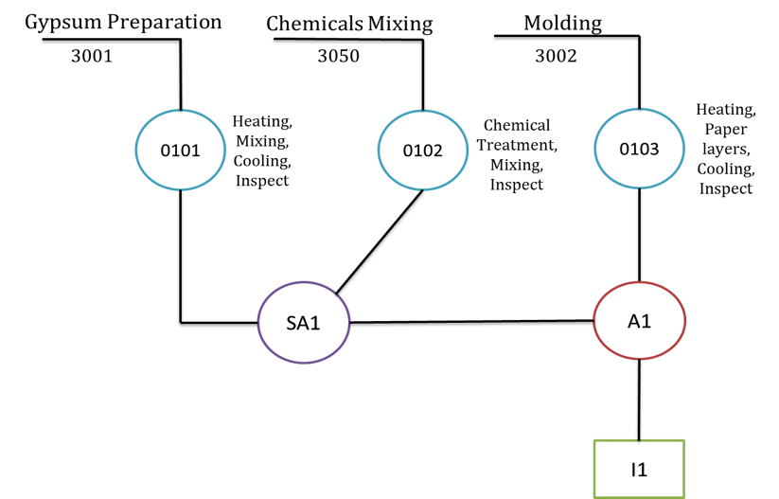
Figure 6. Operation Process Chart for Drywall/

Figure 6 shows the separation of the three mayor components of the manufacturing process. The blue circles represent a process that the mayor components need to go through. The purple circle represents a sub assembly that the process will encounter, and that at the end will form part of a mayor assembly. The Red circle represents a mayor assembly where the sub-assembly and other components meet. Finally, the green square represents an inspection in the process. It is important to mention that at each process point, measurements will be taken in order to ensure quality of the product. Also, in order to ensure that the exact amount of glass nanoparticles are mix, a digital balance will be use as well as fix containers that will aid in the mixing of the components. The gypsum will be mix with the glass nanoparticles and water using a stucco mixer and a battery drill. This process will be the same for all the mixes with different percentages of glass nanoparticles.

Precedence Chart
In order to have a better visual of the flow of the OPC, a precedence chart is created. The precedence chart only has the number of the process, subassemblies, assemblies, and inspections. This type of chart is used when the number of each step in the process flow is already known. The precedence chart starts with the circle 0100 that means the start of the process. This start can be seen as the preparation of the product, or the receiving of raw material in a manufacturing plant.

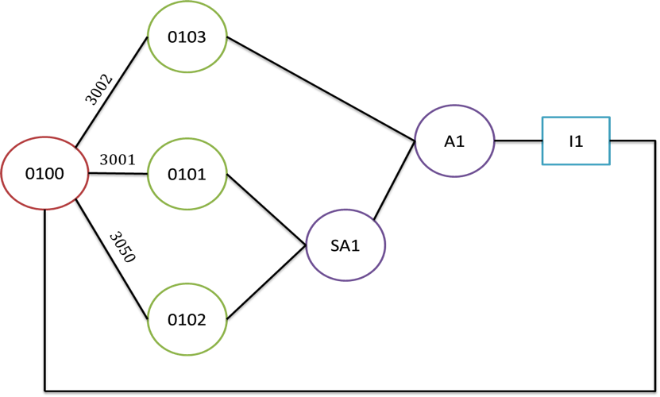/
Figure 7. Precedence Chart for Drywall Manufacturing Process

From Figure 7, it can also be spotted the three components from the OPC, and the flow that each one of them go through. The subassembly 1 is the mixing of the prepare gypsum and the chemicals used for the paste of the drywall. The assembly 1 is the assembly of the past with the paper and put in the mold for its preparation on the furnace. Lastly, the inspection 1 is the final inspection of the product to ensure that the product came out in excellent conditions from the furnace. This precedence chart will be followed every single time of the creation of a prototype in order to ensure quality in the product.

Bill of Materials

In order to complete the production of the next generation drywall prototypes some materials needed to be purchase. The bill of materials provides the information of each one of the components that were purchase in order to build the first prototype.

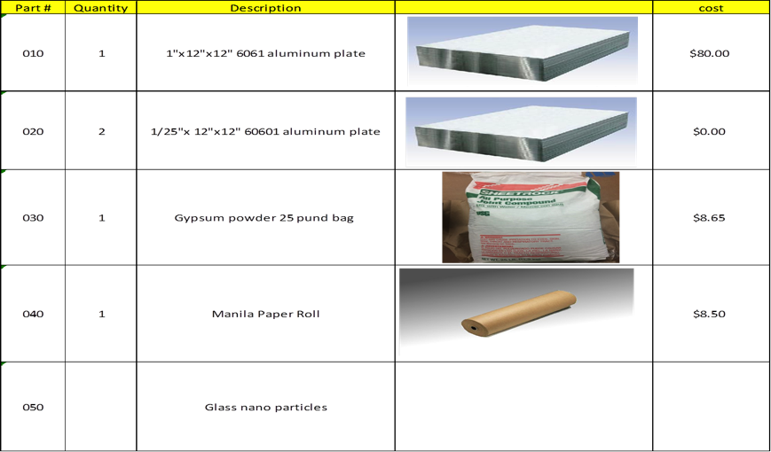///
Table 20. Bill of Materials for Next Generation Drywall

The first item in the list is a 1” x 12” x 12” 6061 aluminum plate. This iteam cost $80.00 dlss including the purchase price and the delivery cost. This item was used in the construction of the transfer mold for the creation of the gypsum prototypes.
The second item in the list is a ¼” x 4’ x 5’ sheet of 6061 aluminum plate. This item was of no cost for the team because it was donated to the team from the technician Hector Arteaga. This item will be use in the creation of the lid of the transfer mold. With the dimensions of the aluminum sheet it is enough to create both lids.
The next item in the list is gypsum power ready to be mixed. It is a 25-pound bag that cost $8.65 dlls. This item will be used in the creation of the paste for the gypsum board.
The forth item in the list is a roll of Manila paper. It is a 200 ft roll that cost $8.50 dlls. This roll will work as the top and bottom paper layer for the gypsum board prototype.
The last item in the list is the glass nanoparticles. These particles are made out of recycle glass with resources available for the team. The cost of $0.03 is per gram of glass nanoparticle. This an estimated cost due to the availability and ease of production of the material.

Design Validation

Test Protocols
In order for a gypsum drywall to have an acceptance of type x in the market, it must go through test validation from the standards of the ASTM. A gypsum drywall will not only be tested for its fire resistance and flame retardant, but its hardness, flexural strength, humidity deflection, and nail pull resistance as well. The test protocols to follow, in order for the data to be considered, are found in the ASTM standards. Also, as well as the test protocols, the expected results are stated in the standards in order for a product to be consider type x. The following is a table with the test ID’s of the standards where the protocol was found, and expected results from the testing:

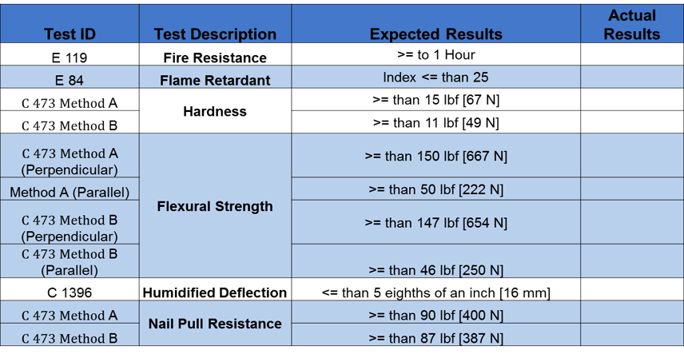
Table 21. Test Protocols /

From Table 23 it can be spotted that the each one of the descriptions has its test id and the expected value. For fire resistance, the protocol was found in the ASTM E 119 with an expected result of at least one hour. For the hardness, the test protocol was found in the ASTM E 84 with an expected index of at least 25. The next description is the hardness of the drywall, which its test protocol is found by two methods, A and B. Both methods are found in the ASTM standard C 473. The flexural strength is a continuation of the methods A and B from the hardness, with the difference that they are tested parallel and perpendicular. All 4 protocols are found in the ASTM C437 standard with an expected value of 150 lbf for A perpendicular, 50lbf for A parallel, 147 for B perpendicular and finally 46 lbf for B parallel. The test protocols for the humidified deflection are found in the ASTM C 1396 standard, with an expected value at most 5/8” of deflection. Lastly, Nail pull resistance test protocol can be found in the ASTM C 437 standard. Similarly to hardness, it has two methods to be tested. For method A the expected value has to be at least 90 lbf, and for method B at least 87 lbf.

- Economical Analysis.

Design Failure Mode Effects Analysis (DFMEA)
This tool helps identifying all possible failures in the mold and drywall. In the following tables, information about the function, potential failure mode, severity of the failure, causes of the failure, frequency or how often the failure can happen, current process control of the failure, and ability to detect the failure is described. The score of severity, frequency and ability to detect the failure in a scale of 1 to 10 where 1 is extremely unlikely and 10 is inevitable; provide guidance for ranking potential failures in the order they should be addressed.

FAILURE MODE AND EFFECTS ANALYSIS FOR MOLD
Process Function | Potential Failure Mode | Severity | Potential Cause(s)/ Mechanism(s) of Failure | Frequency | Current  Process  Controls | Ability to Detect | RPN
Form and shape drywall | Failure to resist high temperatures | 8 | Improper machine set up | 2 | Operator training and instructions | 6 | 96
 | Breaks | 9 | Improper machine set up | 4 | Operator training and instructions | 8 | 288
Table 22. Failure Mode And Effects Analysis for Mold

For the mold, two potential failures were found, which are:
- Failure to resist high temperatures that can be caused as a result of improper machine set up representing a severity of 8, frequency of 2 and ability to detect of 6, giving a total risk priority number of 96.
- And the potential failure that the mold could break as a result of improper machine set up representing a severity of 9, frequency of 4 and ability to detect of 8, giving a total risk priority number of 288.
Based on the risk priority number, the failure that should be addressed first is when the mold breaks and controlled by training the operator and following strictly the instructions to set up the machine.

FAILURE MODE AND EFFECTS ANALYSIS FOR DRYWALL
Process Function | Potential Failure Mode | Severity | Potential Cause(s)/ Mechanism(s) of Failure | Frequency | Current  Process  Controls | Ability to Detect | RPN
Construction Support, Fire Resistance, lower vibration transmission | Not enough fire resistivity | 9 | Not proper gypsum mixing | 4 | Standards Instructions how to prepare gypsum mix | 6 | 216
 | Low soundproof index | 4 | Improper gypsum mixing and not proper thickness | 5 | Standards Instructions how to prepare gypsum mix | 3 | 60
 | Low Humidity | 7 | Not proper gypsum mixing | 5 | Standards Instructions how to prepare gypsum mix | 3 | 105
Table 23. Failure Mode And Effects Analysis for Drywall

For the drywall, three potential failures were found, which are:
- Not having enough fire resistivity that can be caused by not mixing the gypsum properly, representing a severity of 9 frequency of 4 and ability to detect of 6, giving a total risk priority number of 216.
- Having low soundproof index a result of improper gypsum mixing and not proper thickness, representing a severity of 4, frequency of 5 and ability to detect of 3, giving a total risk priority number of 60.
- Having low humidity a result of improper gypsum mixing, representing a severity of 7, frequency of 5 and ability to detect of 3, giving a total risk priority number of 105.

Based on the risk priority number, the failure that should be addressed first is when drywall does not have enough fire resistivity, which can be controlled by following the standards instructions how to prepare gypsum mix.

Quality Assurance
Control charts will be used after the process is standardized to maintain a desired level of quality in Next Generation Drywall. This will help to pay attention to every stage of the process of production.

Safety Issues
There is selected safety information for glass Micro & Nano particles that should be taken in consideration while working in the project, which are:
- The acute toxicity of the particles: None known
- The chronic toxicity of the particles: None known
- Micro & Nano particles can cause eye irritation and may cause respiratory irritation
- People working with the particles should avoid breathing dust and wear Personal Protective Equipment (PPE)

Source: MSDS#031512 (Precision Recycling Industries, Cornelius, NC (Revised 03/20/2012)

Summary
A new opportunity to build next generation drywalls using glass micro- & Nano-particles from recycled glass was identified. Expected benefits include environment friendly fire resistant materials, more energy savings and better noise attenuation. Also, reproducible sample drywalls using standard & proposed new drywalls with varying percent of glass nanoparticles was developed.
For future work, test protocols for fire resistance and insulation will be used as well as new protocols for noise attenuation using University resources that will be developed.

References

Buildgp.com, (2014). Georgia-Pacific Building Products - Plywood, OSB, Gypsum Boards, Lumber. [online] Available at: http://www.buildgp.com [Accessed 1 Dec. 2014].
Continental-bp.com, (2014). Home | Continental. [online] Available at: http://www.Continental-bp.com [Accessed 1 Dec. 2014].
Homedepot.com, (2014). Cyber Monday Online Shopping Ads. [online] Available at: http://www.Homedepot.com [Accessed 1 Dec. 2014].
Lowes.com, (2014). Cyber Monday Deals at Lowe's: Save on Appliances, Tools, Hardware. [online] Available at: http://www.lowes.com [Accessed 1 Dec. 2014].
Nationalgypsum.com, (2014). National Gypsum Company, Drywall, Cement Board, Gypsum Board, Finishing Products. [online] Available at: http://www.nationalgypsum.com/about/index.htm [Accessed 1 Dec. 2014].
Perilli, D. (2014). Gypsum industry events, news & research. [online] Globalgypsum.com. Available at: http://www.globalgypsum.com [Accessed 1 Dec. 2014].
Usg.com, (2014). Building Materials | Building Products & Solutions | USG. [online] Available at: http://www.USG.com [Accessed 1 Dec. 2014].

